**Online Bus Reservation System**

**TravelToday.com**

*Developed by*

*Zubin Kadva, Ravi Jaswani*

**TRAVELTODAY.COM**

**ONLINE BUS BOOKING**

**SUBMITTED IN FULLFILLMENT OF THE REQUIREMENT IN THE DEGREE,**

**BACHELOR OF SCIENCE IN INFORMATION TECHNOLOGY**

**UNDER THE GUIDANCE OF**

**PROF: KAUSHAL SHAH**

**DEPARTMENT OF BECHELOR OF SCIENCE IN INFORMATION TECHNOLOGY**

**KISHINCHAND CHELLARAM COLLEGE**

**UNIVERSITY OF MUMBAI**

**ACADEMIC YEAR 2011-2012**

**ACKNOWLEDGEMENT**

One of the great pleasures of writing this project book is acknowledging the efforts of many people whose names may not appear on the cover but whose hard, work, cooperation, friendship 0report on “TRAVELTODAY”.

We are very much thankful to our Mr Kaushal Shah who was kind enough to give us an opportunity to do this project work.

Being our Guide he imparted us immense administration knowledge and provide us a clear background about the problem scenario which help us in laying a strong foundation of our project.

It give us pleasure in presenting this project book whose justification will never sound good if we do not impress our vote of thanks to all our staff members of IT department of our college for allowing us to work in the lab, without whose help our project and its thesis would have neither begun nicely nor would have had reached the best ending.

We are much thankful to our project guide and all other teaching and non-teaching staff for their suggestion, reviews, encouraging criticism and time to time help and support which lead us to achieve our goals and overcomes the difficulties.

Last but not the least we are thankful to our parents & friends whose gave us the much needed moral support & encouragement which made developing this project a work of sheer joy & satisfaction. Thank you all once again.

**PREFACE**

This project has been accomplished through the help of advanced computer programming language.

The project will allow the user to book bus tickets, receive e-mail notifications and SMS notifications regarding the details of his/her travel along with other relevant information.

Also it allows the user to view the types of buses that we offer along with the various accommodations available in the respective cities destined for arrival.

It has a colorful interface to keep it different from standard looking packages.

The report we are presenting further is for the user who want to know about functions of the project and to operate the packages.

It has combined the power of Java Server Pages and JavaScript with Microsoft SQL 2008 R2 to give the best result.

We have strived to make this project as error free as possible.

*Reserved for certificate*

**CONTENTS**

1. **INTRODUCTION**
   1. Objective & scope of project
2. **SYSTEM ANALYSIS**
   1. Gantt Chart
   2. Existing System
   3. Requirement Analysis
   4. Proposed System
3. **SYSTEM DESIGN**
   1. System Design Approach
   2. Database Design
      1. Database Concepts
      2. Normalization
   3. Entity Relationship Diagram and Table Structure
   4. Data Flow Diagram
   5. Context Level Diagram
   6. Use Case Diagram
4. **SYSTEM IMPLIMENTATION**
   1. System Testing
   2. Change over
   3. Output Screens
   4. Cost Analysis
5. **CONCLUSION**
6. **FUTURE ENHANCEMENT**
7. **BIBILOGRAPHY**

**SYNOPSIS**

The aim of this project is to provide a website for Online Bus Reservation which provides a procedural approach for booking / cancelling bus ticket records into a single database.

All the details are stored and can be modified easily and very efficiently. The transactions done by the organization are also kept in to the table and can be used whenever needed.

Various reports can be generated using this website.

**MINIMUM HARDWARE / SOFTWARE REQUIREMENT FOR THE PROJECT**

**PROCESSOR** : Intel Pentium 3 or above

**MEMORY** : 128 MB RAM or Higher

**HARD DISK** : 4 GB or more

**POINTER** : Touch pad

**OTHERS** : Printer

**FRONT-END** : Web Browser, Apache Tomcat Server

**BACK-END** : Microsoft SQL 2008 R2

**OPERATING SYSTEM** : Windows XP / Vista / 7 / Java Compatible

**I N T R O D U C T I O N**

**ABOUT THE ORGANIZATION**

TravelToday.com is an organization established with the intention to develop business in bus dealing.

**OBJECTIVE OF PROJECT**

**Following details are covered up by this project.**

* *Bus Information*
* *Accommodations*
* *Booking / Reservation*
* *Generation of Ticket Prints / SMS Facility*

In this project all records are stored in the form of table inside the database.

Seats Available or Booked or Reserved are checked whenever needed.

All calculation is done by the system & computerized ticket is given to the customer.

Details can be updated when required.

The system is user friendly.

It is reliable and one time investment.

**SCOPE OF PROJECT**

* The proposed system computerizes all records maintained in database.
* Passenger Details, Payment details can be checked whenever necessary

**S Y S T E M**

**A N A L Y S I S**



**Project Development Gantt chart**

**EXISTING SYSTEM**

The current system is manually operated.

All records are maintained in the register.

Every time a reservation is made, it is entered in to a register.

The register can be checked for reservation details.

A number of registers are maintained.

Calculations are done manually.

The customers are given a manual bill.

At the end of the day the manager checked the daily report.

All the payment & transaction done are stored in a register.

After a fixed period of time, the documents are given to the external accountant to solve the accounting problem.

**DISADVANTAGES OF THE EXISTING SYSTEM**

All the transaction is stored in a register, so we have to maintain a number of files, which is a big drawback.

All data is entered manually, so there are chances of data entry errors.

Reports are generated handwritten.

Chances of misusing data.

Anybody can access details of customer.

**REQUIREMENT ANALYSIS**

The Concept was very clear and we had no problems in understanding them. It consists of

* A simple, easy to understand web interface.
* Enables the user to view / book bus tickets in real-time from the Web Site automatically.
* Enables generation of E-Ticket to get the summary.
* Enables graphical view of already stored data.

**FACT FINDING TECHNIQUE**

The requirement analysis can be done by the system analyst by using various techniques. The system analyst must be a skilled person; he should have good communication capabilities.

The precautions which can be taken are as follows.

**ON SPOT OBSERVATION**

The on spot observation gives many clues regarding the project. It highlights the problems of the existing system. The problem regarding the data retrieval and data storage and also loss of data are highlighted during this.

**INTERVIEWING**

As we are concerned with the fact, finding the interview is most important. By this, we can get a complete view of the requirement and crosscheck whether the existing system is capable of doing so.

**REVIEWING RECORDS**

Various documents can be studied.

These documents are studied for understanding the current method of data recording. This informs us about the actual data recorded.

**Java Server Pages (JSP), JavaScript and Microsoft SQL 2008 R2**

JSP is selected because it is one of the leading rapid web development tools available in the market for developing web sites in the client/server environment. JSP is a type of java technology, hence, it is more flexible, and user friendly, easy to learn and more importantly, it is platform independent. That means it can run on any operating system irrespective of the hardware configuration.

* JSP uses a network.
* Modifications can be done faster and easier.
* Access time is much lesser.
* Does not require training the application to manage the data base.
* It can be used in many systems.

Microsoft SQL 2008 R2 allows users to create a new database and examine or map the structure of existing external database in a variety of formats.

Formats that you can create with other database managers.

**THE PROPOSED SYSTEM**

The proposed system is the package in JSP.

The front-end is JSP / JavaScript and all data is stored in the database.

The back-end is Microsoft SQL 2008 R2.

**FOLLOWING ARE THE ADVANTAGES OF THE PROPOSED SYSTEM**

* Data is in organized manner.
* Saves lots of humane power, thus money.
* As compared to register lockers a computer requires a considerably small amount of space.
* It is very easy to store and transfer data through computer peripherals like CD-ROMs.
* Real-Time data is logged along with real time plotting of reports.
* Already recorded data can also be viewed in the form of reports and data.
* Data migration across all the branch offices possible.
* The storage provided by the computer is enormously larger as compared to registers.
* Data accuracy is highly guaranteed in real-time situation.

**S Y S T E M**

**D E S I G N**

**DESIGN METHODOLOGY**

**The software design can be classified into two types:**

* Process Oriented System
* Data Oriented System

Process Oriented Systems are driven by their functionality.

In this system it is the process that is complicated.

Data Oriented Systems are those that are driven by their concentration of data.

It is the data that is critical, not the process to handle it.

There are several methodologies that software engineers follow for development of software.

These methodologies follow the structure design approach.

Structure analysis is the process of defining requirements for the problem.

During analysis software engineers examine the need of user, and define the properties that the system should proceed to meet those need.

They also identify the system constraints and performance requirements.

**DATABASE DESIGN**

**DATABASE**

A database is a collection of files that works together to form a complete data management system.

We can even say database is an organized collection of data.

It could be looked upon as files that contained tables, indexes and queries, a table is one data file, and database is collection of those tables.

A table is a collection of data that can be stored as rows and columns.

In database terms rows are called as record & columns are called as fields.

The fields available in the database can be of different types.

**Following are some important fields of the database.**

**PRIMARY KEY**

A primary key is one that uniquely identifies each record in the tables. A primary key is advisable in tables, because it speeds up operations.

**FOREIGN KEY**

A foreign key is one that helps to join two tables or links two tables. When u define a column foreign key then u have to give the name of reference column of other table u have to link this table to. With foreign key whatever changes are made in the reference column are made in the foreign column.

**NORMALIZATION**

Normalization is a process of putting things right, making them normal.

In the relational database the terms also have specific mathematical meaning having to do with separating elements of data into affinity groups, and defining the normal relationship between them.

**Normalization is commonly discussed in terms of FORM:**

FIRST NORMAL FORM

It is done by moving data into separate table where the data in each table is of the similar type, and giving each table a primary key.

SECOND NORMAL FORM

It entails taking out data that only dependent on the part of key.

THIRD NORMAL FORM

It means of getting rid of anything in the table that does not depend solely on a primary key. Anytime the data is in the third normal form.

**SYSTEM CONCEPT FOR DATA MODELING**

**NOTATIONS USED IN E-R DIAGRAM**

E

It represents entity set

A

It represents Attributes

A

It represents primary key Attributes

R

It represents relationship set

Line attributes to entity sets and entity sets relationship sets



*BusReservationSystem Entity Relationship Diagram*

**Entity 1 – Bus_Master**



|  |  |  |  |
| --- | --- | --- | --- |
| Field Name | Description | Data Type | Constraint |
| bid | Bus ID | varchar(10) | Primary Key |
| bname | Bus Name | varchar(30) | Not Null |
| type | Bus Type (Normal, Sleeper) | varchar(10) | Check |
| ac | Air Conditioned | varchar(3) | Not Null |
| number_booked_seats | Number Of Booked Seats | int | Not Null |
| max_seats | Number Of Maximum Seats | int | Not Null |
| available_seats | Number Of Available Seats | int | Not Null |
| booked_seats | Name Of The Booked Seat | text |  |
| rid | Route ID | varchar(10) | foreign key references Route |

**Entity 2 - Route**



|  |  |  |  |
| --- | --- | --- | --- |
| Field Name | Description | Data Type | Constraint |
| rid | **Route ID** | **varchar(10)** | **Primary Key** |
| fare | **Cost Per Seat** | **money** | **Not Null** |
| source | **Source** | **varchar(20)** | **Not Null** |
| destination | **Destination** | **varchar(20)** | **Not Null** |
| departure | **Time Of Departure** | **time** | **Not Null** |
| arrival | **Time Of Arrival** | **time** | **Not Null** |

**Entity 3 – Passenger**



|  |  |  |  |
| --- | --- | --- | --- |
| Field Name | Description | Data Type | Constraint |
| pid | **Passanger ID** | **int** | **Primary Key** |
| rid | **Route ID** | **varchar(10)** | **foreign key references Route** |
| bid | **Bus ID** | **varchar(10)** | **foreign key references Bus_Master** |
| pass_first_name | **First Name** | **varchar(20)** | **Not Null** |
| pass_last_name | **Last Name** | **varchar(20)** | **Not Null** |
| pass_address | **Address** | **text** | **Not Null** |
| pass_sex | **Gender (M, F)** | **char(1)** | **Check** |
| pass_email | **Email Address** | **varchar(20)** | **Not Null** |
| pass_phone1 | **Landline Number** | **varchar(11)** |  |
| pass_phone2 | **Mobile Number** | **varchar(10)** | **Not Null** |
| username | **Username** | **varchar(10)** | **Not Null** |
| booked_seats | **Name Of Booked Seats** | **text** |  |
| travel_date | **Date Of Travel** | **varchar(max)** |  |

**Entity 3 – Payment**



|  |  |  |  |
| --- | --- | --- | --- |
| Field Name | Description | Data Type | Constraint |
| receipt_number | **Payment Receipt Number** | **int** | **Primary Key** |
| pid | **Passenger ID** | **int** | **foreign key references Passenger** |
| amount | **Total Fare** | **money** |  |
| payment_date | **Date Of Payment** | **varchar(max)** |  |

**Entity 3 – Login_Master**



|  |  |  |  |
| --- | --- | --- | --- |
| Field Name | Description | Data Type | Constraint |
| username | **Username** | **varchar(10)** | **Primary Key** |
| password | **Password** | **varchar(10)** | **Not Null** |
| secret_question | **Secret Question** | **varchar(30)** | **Not Null** |
| secret_answer | **Secret Answer** | **varchar(30)** | **Not Null** |
| account_type | **Administrator, Site Member** | **varchar(6)** | **Not Null** |

**DATA FLOW DIAGRAM**

DFD is a graphical aid for defining system inputs, process and outputs.

It represents flow of data through the system.

DFD are used in modern method of system analysis.

They are simple to extent that the type of symbols and rules are very strict.

DFDs serve following purposes.

Provide a graphical tool, which can be used by the analyst to explain his understanding of the system to the user.

They can convert readily into a structured chart, which can use in design.

They help the system designer to understand system very easily.

DFDs show flow of data through the system.

It views a system as a function that transforms the inputs into the output.

The DFD aims to capture the transformation that take place within a system to the input data so that eventually the output data is produced.

The agents that perform the transformation of data from one state to another are called a process.

The process is shown by circle and data flows are represented by named arrow entering the process.

Rectangle represent source.

**NOTATIONS USED IN DFD**

It represents processing nodes

It represents data flow

It represents data store

It represents entity

It represents process transaction



*BusResrvationSystem Basic DFD*

**DFD Scenario**

The above shown diagram is a basic representation of how the flow of data will take place.

Firstly, a customer visits the site and takes a look at the various other options available apart from the core of the site i.e. booking.

After viewing all these details, the customer then registers himself and goes ahead with the booking.

He / she check the available routes and select the one appropriate to him / her.

After viewing the results, the passenger checks for its availability and thus, reserves a ticket.

Pays the fare or if he / she wish, can also cancel the booked ticket.

These two distinct scenarios are explained in the next section.



**Booking DFD Scenario**

This DFD provides a more descriptive aspect of the concept of booking.

Assuming that the customer has already registered him/herself, proceeds with the first step towards achieving a reserved bus ticket.

After selecting the vital attributes, the customer proceeds to view the search result pertaining to his / her criteria.

Selecting a bus, will transfer him / her to the booking page wherein the customer selects the desired seats.

The seats previously reserved by other customers are also shown here.

After selecting the seats, the site accepts the request of the customer for cash on delivery.

The customer then receives a call from the traveltoday team confirming his / her request.

The customer receives a ticket and an SMS as mTicket.

Now the customer can enjoy his / her trip and maybe give their valuable feedback.



*Cancellation DFD*

**Cancellation DFD Scenario**

Assuming that the customer has logged in and has booked a ticket, he / she is given the ability to cancel his / her ticket.

The customer cancels his / her ticket.

After this action, the booked tickets of the corresponding user are deleted from the database and the appropriate changes are made in the bus database, thus removing the reserved seats.



**Bus Reservation System Context Diagram**



**Ticket Booking Use Case Diagram**



**Cancellation Ticket Use Case Diagram**

**S Y S T E M**

**I M P L E M E N T A T I O N**

**TESTING AND IMPLIMENTATION**

Implementation is a process that is involved in the complete development of software.

The implementation process based on the design methodology.

There are several of procedures to be followed while implementing the software.

Before installing the proposed system we will have to supply the client, a daily report regarding the complete detail and functions of development system.

During the implementation stage the client will never leave the existing system until client is fully satisfy with the proposed system and also the initial stages both the existing and propose4d system will be going hand in hand since some time is require for the updating of transaction.

This project is tested by unit tests and integration tests.

**CHANGE OVER**

The change over to a new system is usually executed against a comprehensive plan contains

* *Identification of all activity require during the change over*
* *Responsibility for each activity*
* *Scheduled for each activity*
* *Step to be followed for each activity and the criteria for knowing when the activity is to be start and to end*

**OUTPUT SCREENS**

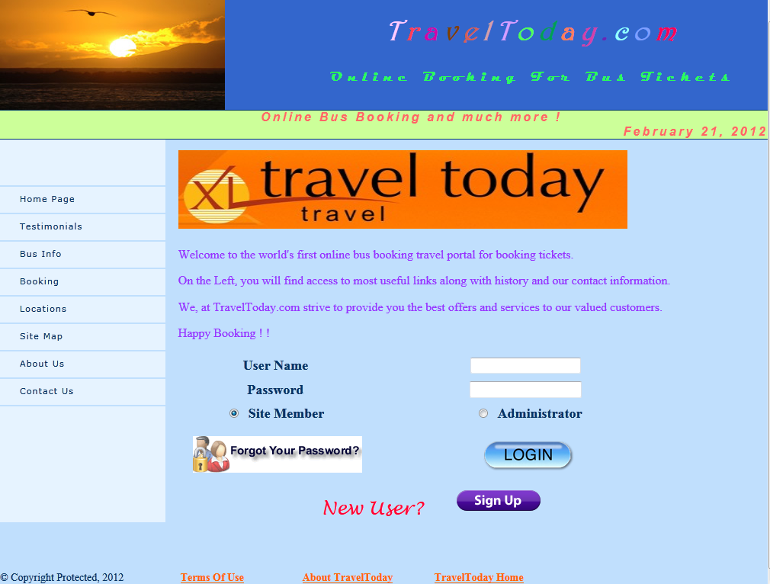

**TravelToday.com Home Page**

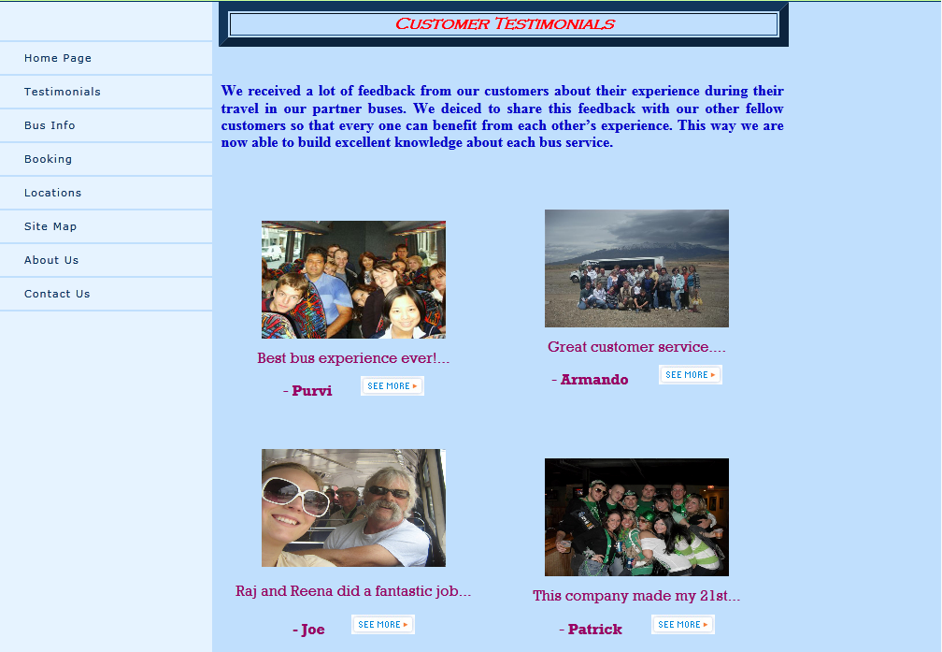

**Customer Testimonials**

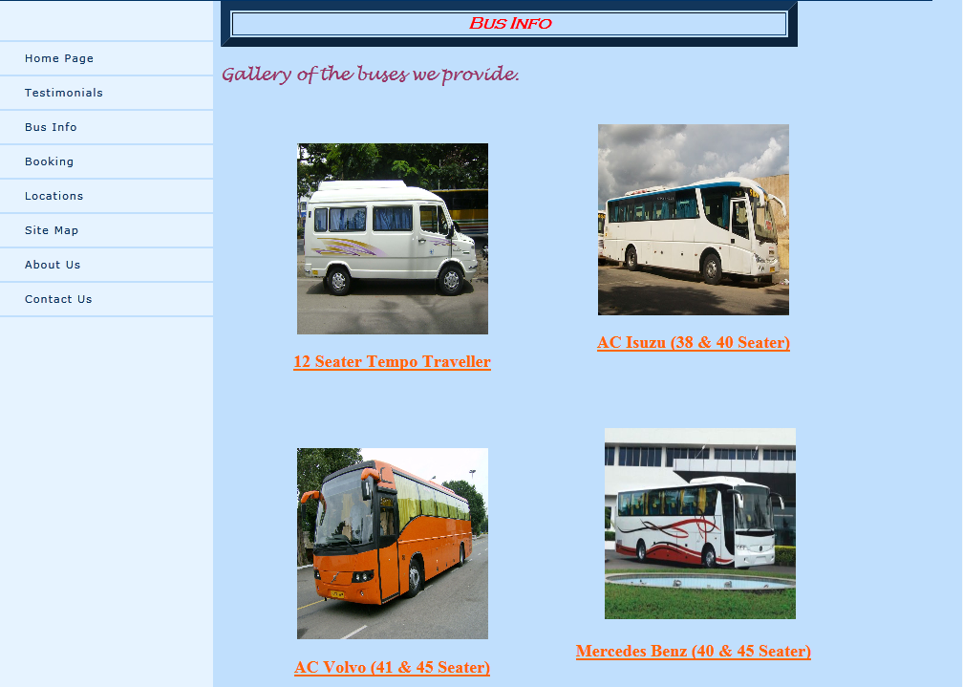

**Bus Info**

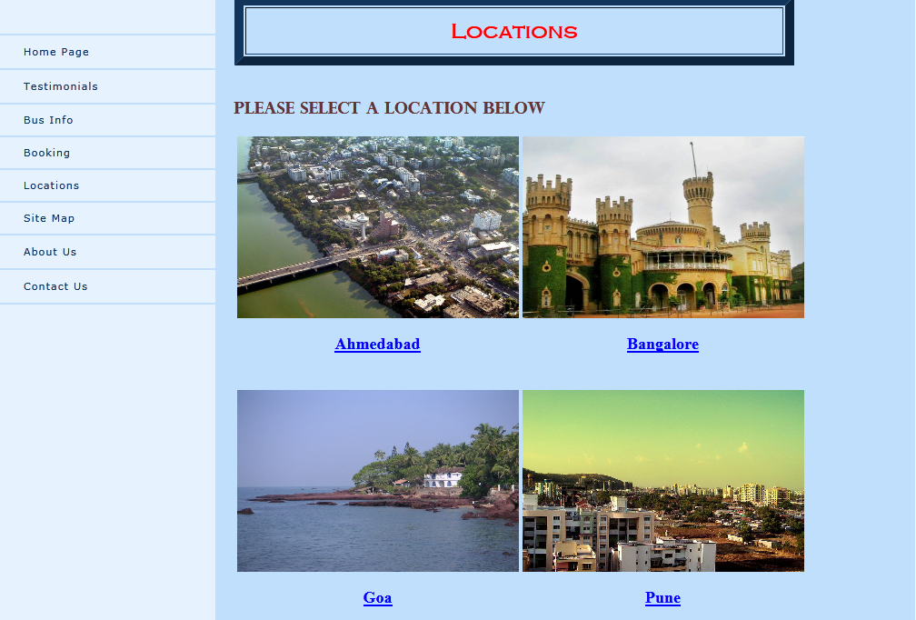

**Locations**

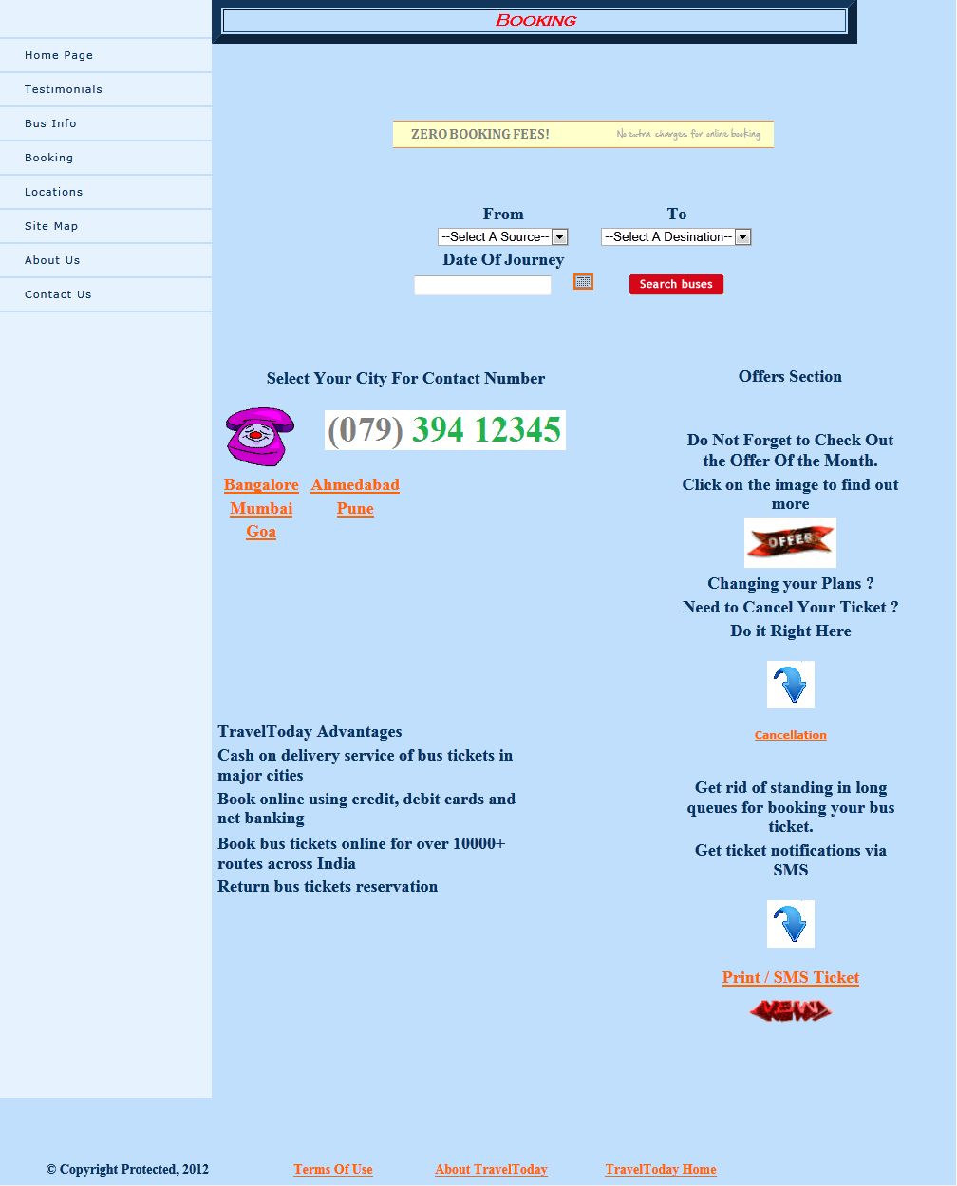

**Booking**

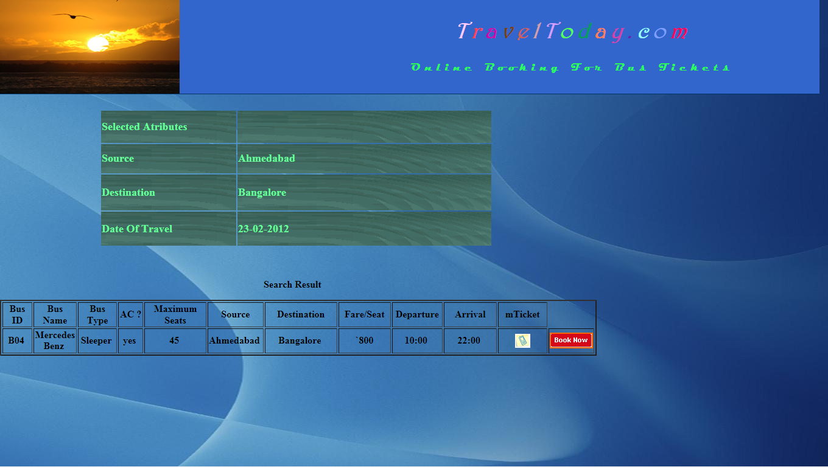

**Search Result**

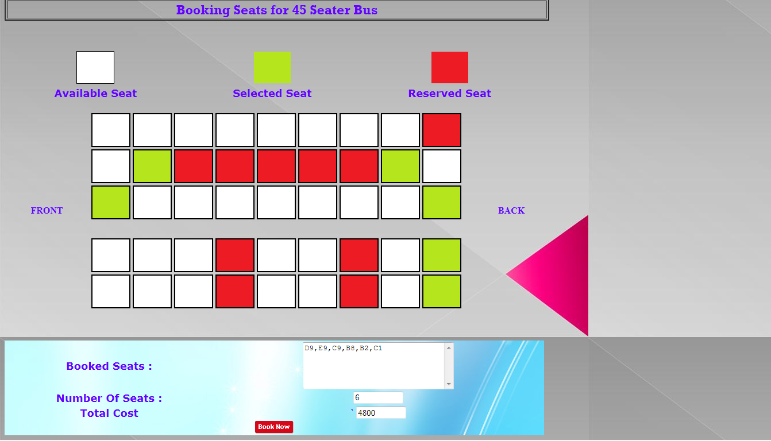

**Booking the seats**

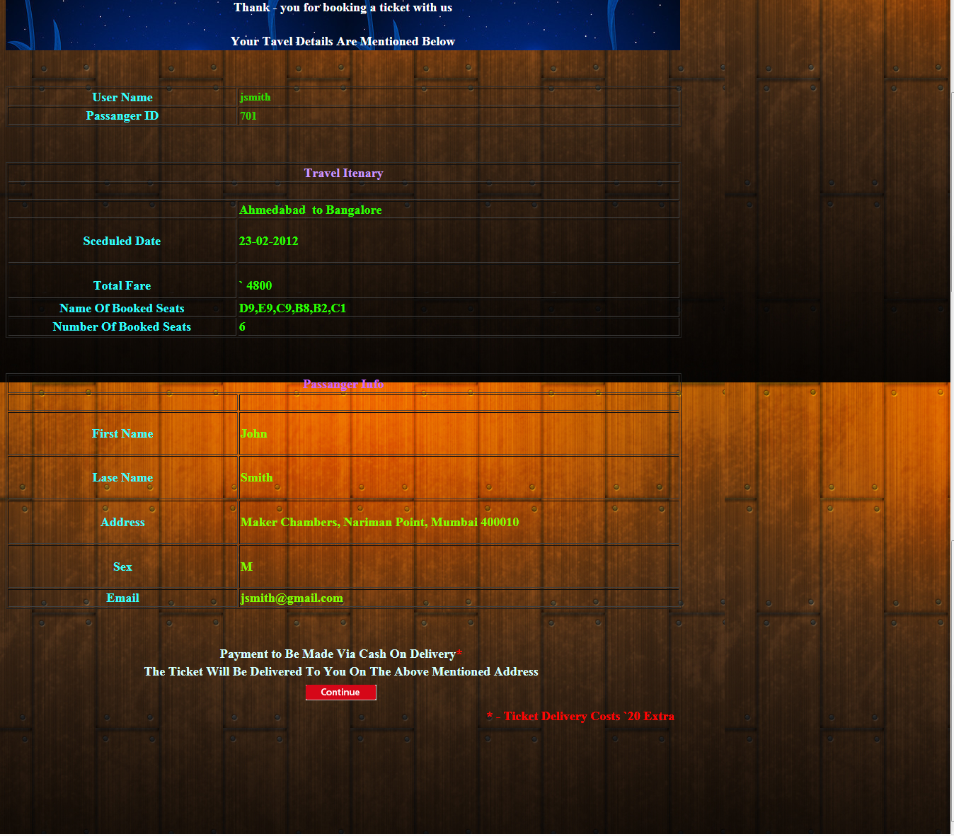

**Travel Itinerary**

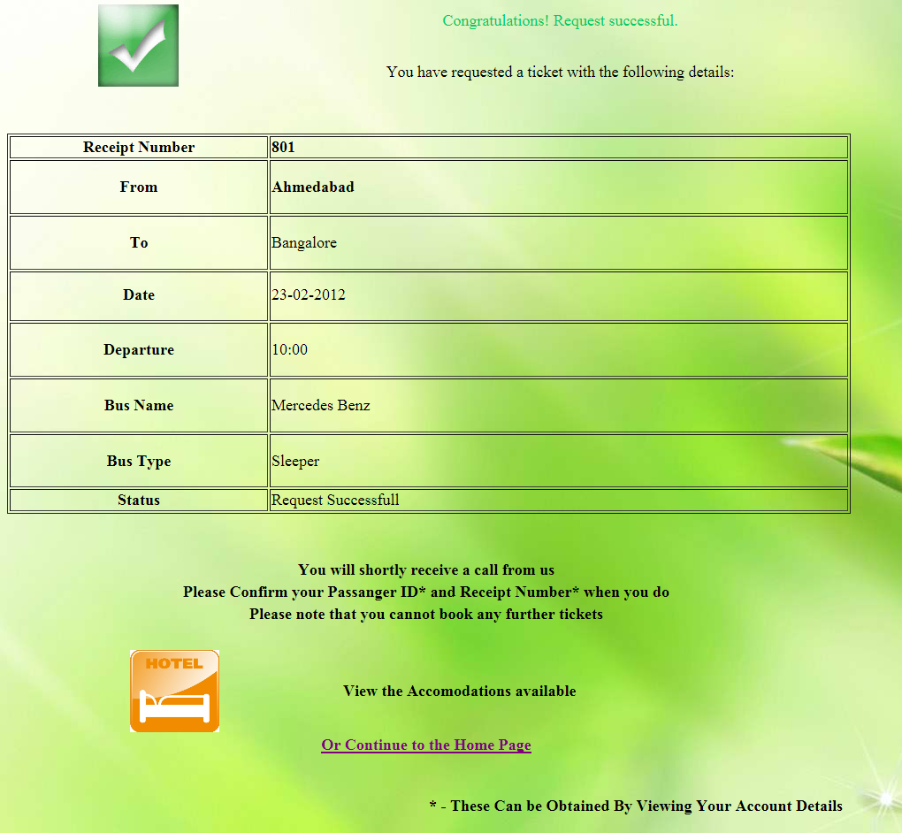

**Payment Request Made**

**`**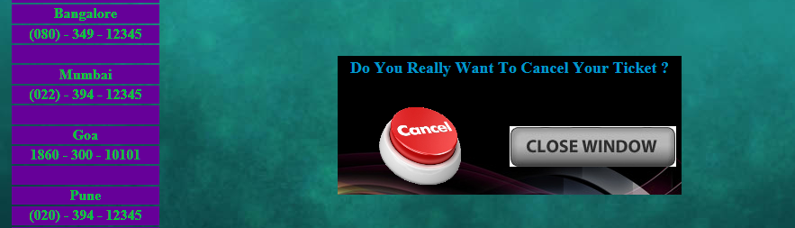

**Confirmation of cancellation**



**Ticket Reservation Revoked**

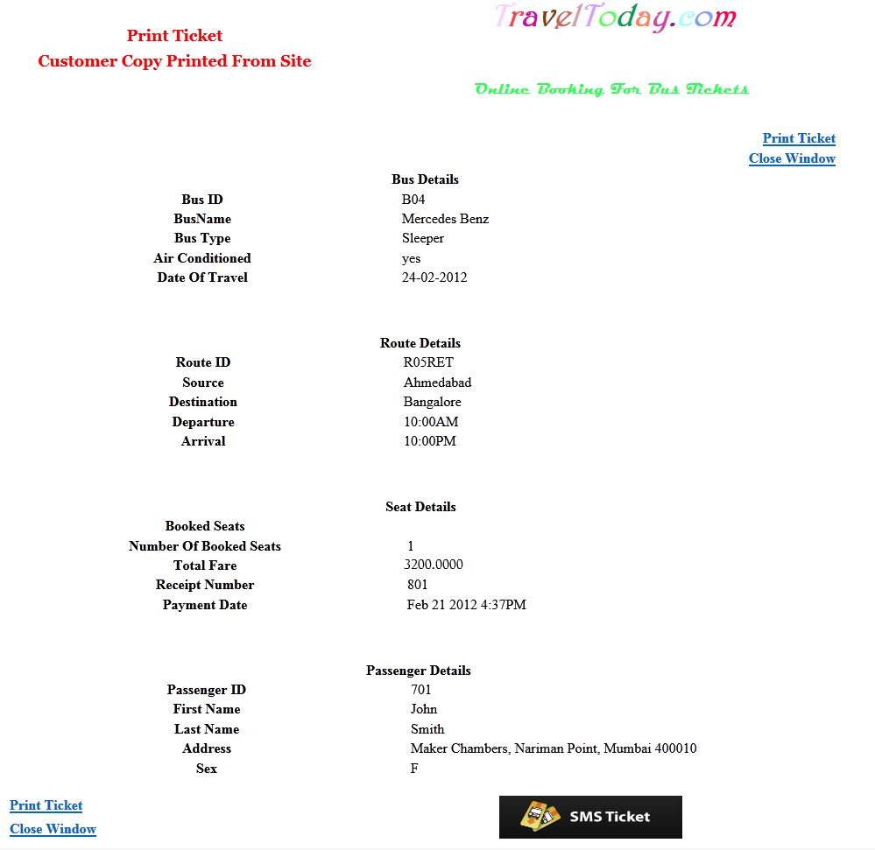

**Print Ticket**

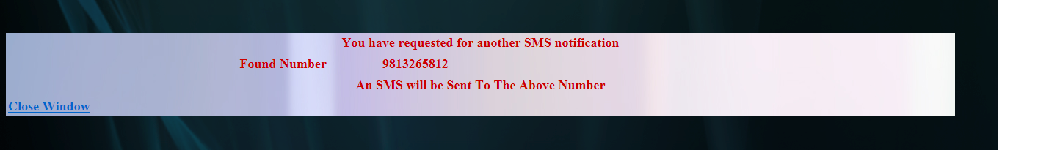

**SMS Ticket**

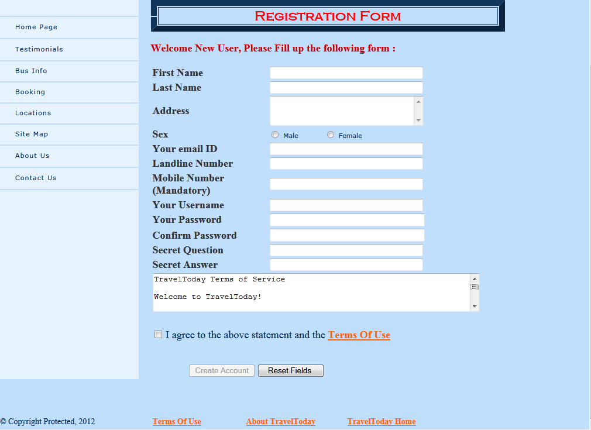

**Registration From**

**COST ANALYSIS**

**How Much Should a Web Site Cost?**

Determining how much a web site should cost is one of the most frequently asked but rarely answered questions in the web design world.

Even now, with millions of web sites online, there exists no magic formula for calculating either the cost of a new web site or the cost of a redesign.

These include historical web site development costs and web design costs for different components as well as current web site features and design costs.

**Historical Perspective: How Much Should a Web Site Cost?**

Like other goods and services, the cost associated with designing, developing and building a web site has changed over time.

**The below cost quote is an estimate result generated from WebPageFX.com**

|  |  |  |  |
| --- | --- | --- | --- |
|  | | Low | High |
| Number of pages | 10 - 50 | **$ 2,000** | **$ 3,000** |
| Style of design | Moderately stylized | **$ 3,000** | **$ 5,000** |
| Copywriting # of pages | None | **$ 0** | **$ 0** |
| SEO w/ Placement Guarantee | 30 keywords | **$ 2,000** | **$ 4,000** |
| Flash or Multimedia | Simple Header | **$ 1,000** | **$ 2,000** |
| Database Integration | Advanced | **$ 4,000** | **$ 10,000** |
| e-Commerce Functionality | Basic | **$ 2,000** | **$ 4,000** |
| CMS | Standard | **$ 2,000** | **$ 4,000** |
| Total Estimated Quote | | **$ 16,000** | **$ 32,000** |

**CONCLUSION**

This project has been designed with our utmost capabilities and efforts.

It has been tested for all possible acceptation keeping in mind, the primary requirement of ‘building a robust system’.

This experience has enriched our knowledge of developing a web application and has proved to be the stepping stone in our carrier.

Also this project gives us lot of knowledge about the booking concept which definitely will help us in our carrier

**FUTURE ENHANCEMENT**

We believe in one line “There is always an inch more to build”.

This means, our website can be enhanced, and will be enhanced further more.

We were bound by certain criteria such as time, money, syllabus permission like professional talent and work experience.

But positively, without these bounding criteria, we would like to enhance this software project and empower it with many more functionalities.

Some functionality our future enhancement includes.

* **Inclusion of stringent security**.
* **Integration with the advanced web.**
* **User star ratings.**

Our current project is a sincere effort to balance all the current limiting criteria but we hope that we can add above functionalities to our current project.

**BIBLIOGRAPHY**

The reference books and material used during this system development are as follows –

